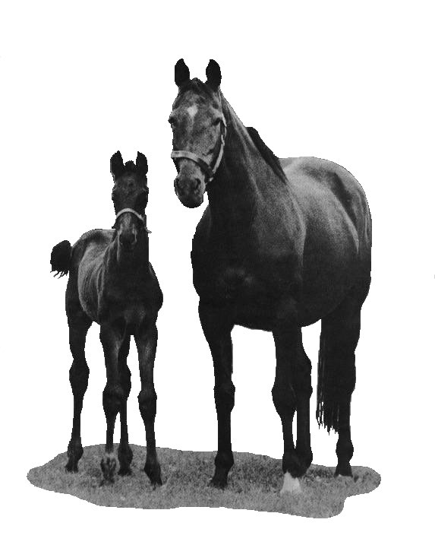

BATSFORD STUD

Breeding Requirements 2026

Batsford Stud observes the current Code of Practice adopted by the HBLB for the Control of Contagious Equine Metritis and other Equine Venereal Diseases for the 2026 Covering Season.

Please Note that all forms and Certificates, including a copy of the Mare’s Passport must be received by the Office PRIOR TO ARRIVAL OF THE MARE, OR FOR WALK-IN MARES PRIOR TO BOOKING A COVER

All paperwork should be emailed to office@batsfordstud.com

Please note: - Mares arriving from outside the United Kingdom and Ireland should not be travelled with non-thoroughbreds or any other equidae unless these meet the same disease screening requirements for CEMO, EVA, EIA and other equine infectious diseases as are laid down in these regulations. All correctly completed international travel documents should accompany the mare.

It is of the upmost importance that mares should be kept separate from all non-thoroughbreds with the exception of foster mares providing that they have been fully tested as per these Regulations. If this is not the case, it should be reported to the Stallion Stud well in advance of covering.

All mares must be correctly vaccinated for EQUINE INFLUENZA. (Primary course of two vaccinations and 6 monthly booster). The latest vaccination must have been given within 6 months of each covering as recommended in the HBLB International Codes of Practice. All vaccinations must be entered in the mare’s passport. If any booster becomes due whilst the mare is at the stud, it will be given by our veterinary surgeon, unless otherwise advised.

A CONTAGIOUS EQUINE METRITIS (CEMO) - LOW RISK MARES require:

Before first time of covering:
One negative clitoral swab test and one negative endometrial swab test taken after 1st January 2026 with the latter taken during oestrus. Swab test results must certify negative culture or PCR results for Taylorella equigenitalis (CEMO), Klebsiella pneumoniae (capsule types 1, 2, & 5) and Pseudomonas aeruginosa by a British Equine Veterinary Association (BEVA) Approved Laboratory or other National Approved Laboratory. The Stallion Stud Manager may, at his or her discretion, on veterinary advice, allow mating to proceed on the basis of satisfactory results from aerobic culture of endometrial swabs if adequate clitoral swabbing has already been carried out. However, the microaerophilic culture or PCR endometrial swab results should be sent to the stallion stud as soon as they are available.

Subsequent walk-ins: Repeat endometrial swab tests during all subsequent oestrus periods must be cultured aerobically or PCR tested for Klebsiella pneumoniae & Pseudomonas aeruginosa, and results certified before the mare is covered. Microaerophilic cultures or PCR testing for CEMO are still recommended and full results should follow afterwards if covering has already taken place.

CONTAGIOUS EQUINE METRITIS (CEMO) - HIGH RISK MARES - those who have had previous contact with CEMO or who originate from countries outside France, Germany, Ireland, Italy and the United Kingdom:

Before first time of covering:

Two negative clitoral swabs taken after 1st January 2026 and at least seven days apart at the home premises or the boarding stud. One negative endometrial swab taken after 1st January 2026 at the home premises or the boarding stud during the oestrus prior to service. Clitoral and endometrial swab test results must certify negative culture or PCR results for Taylorella equigenitalis (CEMO), Klebsiella pneumoniae (capsule types 1, 2, & 5) and Pseudomonas aeruginosa by a British Equine Veterinary Association (BEVA) Approved Laboratory or other National Approved Laboratory in Ireland or France.

Subsequent walk-ins: Repeat negative endometrial swab, to be cultured or PCR tested as above, for each subsequent oestrus period.

B EQUINE VIRAL ARTERITIS (EVA) tests to be taken after 1st January 2026.

1.All mares that have NOT been outside the United Kingdom and Ireland within the last 12 months will require one negative blood test to be taken after 1st January 2026. Seropositive mares will require two blood-tests to be taken a minimum of 14 days apart; these should demonstrate a stable or declining titre.

2. All mares originating from outside the UK and Ireland will require two negative blood tests, the first to be taken within a 28day period prior to arrival in the UK, with the second to be taken at the boarding stud, a minimum of 14 days after arrival before the mare is released from isolation. Similarly, animals that are seropositive for EVA will require two tests to be taken in the UK. These should be taken a minimum of 14 days apart and demonstrate a stable or declining titre.

3. Fillies in Training. At the discretion of the stallion stud fillies walking in for covering from racing yards may be required to have additional tests taken or tests taken closer to covering. This should be discussed with the stallion stud well in advance.

4. NB. If a mare should leave the boarding stud after service or scanning in foal and thereafter wish to return during further oestrus, it may be necessary to provide a second negative EVA test.

These test results must confirm no significant rise in antibody titres (seroconversion). In the event of an inconclusive ELISA Test result the mare will not be accepted for covering until negative or stable/declining paired positive Virus Neutralisation Test results are obtained.

C EQUINE INFECTIOUS ANAEMIA (EIA) tests to be taken after 1st January 2026.

1. All mares that have NOT been outside the United Kingdom and Ireland within the last 12 months will require one negative blood test for EIA to be taken after 1st January 2026.

2. All mares originating from OUTSIDE the United Kingdom and Ireland will require a negative blood test for EIA taken no more than 14 days prior to arrival in this country. A second blood test must be taken at the boarding stud, prior to covering, a minimum of 14 days after arrival. Further blood tests must be taken as required to ensure that the mare is tested within 21 days prior to, and as close as possible to, EACH COVERING until a final blood test has been taken a minimum 60 days after the mare’s arrival in this country.

3. Any mare arriving from GERMANY or ITALY with a foal at foot will require a blood test for EIA to be taken from the foal a minimum of 14 days after arrival in this country.

D STRANGLES.

Batsford Stud require a Nasopharyngeal swab tested by PCR and taken within 7 days of arrival for mares boarding at Batsford. The current BHLB Code of Practice guidelines for the prevention and control of the aforementioned disease will be observed. Owners and managers are required to declare any possible contact or exposure their mares or stud might have had to Strangles over the past two years. On farms where an outbreak of Strangles has occurred mares will only be accepted on receipt of three negative Nasopharyngeal swabs, taken at 5-7 day intervals, over a two-week period.

E WORMING:

In order to minimise the risk of contamination to our paddocks, all horses boarding at Batsford Stud will have worm egg counts taken, be wormed on arrival at the stud, (this will include Equest/Pramox for encysted redworm from mid Jan until mid March) and thereafter at regular intervals with worm egg counts also being taken. Please take this into account when planning your worming programme.

F WALKING-IN MARES:

Booking times for covering: Please note that we will not be able to book a time for covering walk-in mares until all the necessary paperwork has been received by the stud.
Please call the mobile 07899 957355 to book in walking in mares between the hours of 8.30am and 5.30pm

Scan Results:

Mares not boarding at Batsford Stud must be ultrasound scanned for pregnancy no later than 18 days post covering, and the result passed immediately to the Stud Office. We also suggest that follow-up scans should be done at 28 days post covering. Manual examinations at 40+ days post covering are also essential (see Nomination Agreement) and these results must also be forwarded to the Stud Office.

If the mare is not in foal, a barren certificate must be supplied, dated at least 40 days after the last covering date, and signed by a veterinary surgeon. Please supply this as soon as possible, and in any case by 15th October 2026.

G NOTE ON PAYMENT OF ACCOUNTS:
Accounts for keep will be sent out monthly, payable within 30 days. Accounts not settled within this time will be subject to interest of 8% per annum above Barclays Bank plc’s base lending rate.

Nomination Fees are due on 1st October in the year of covering, unless the mare is sold before this date, when it becomes due immediately. If not paid by 31 October, or if the mare is sold after covering, Late payments will be subject to interest of 8% per annum above Barclays Bank plc’s base lending rate. Preferred payment of keep and nomination fees is by BACS.

Covering certificates will be electronically lodged with Weatherbys once all fees are paid, and any cheques cleared, so please allow time (10 working days) for your cheque to clear if you need your covering certificate for a specific date (e.g. if you are sending the mare to the sales.)

Payments made will be allocated to the oldest invoices first, and to interest before principal, so Nomination Fees will not be considered to have been paid in full if there are any previous keep invoices outstanding.

Please note that all invoices will be sent and payments must be made in £ Sterling.

H CHARGES 2026 (All charges are subject to VAT at the current rate)

Accounts not settled within 30 days will be subject to interest of 8% per annum above Barclays Bank plc’s base lending rate.

PLEASE NOTE

a) CONTAGIOUS EQUINE METRITIS (CEMO) - ALL MARES In the case of pregnant mares who have had difficult foalings requiring veterinary attention and antibiotic treatments, an additional clitoral swab should be taken after foaling and more than 7 days after antibiotic treatment has finished, in addition to routine endometrial swabs, in order to rule out acquired Pseudomonas aeruginosa and Klebsiella pneumoniae infections. Providing the pre-foaling clitoral swab was certified negative for Taylorella equigenitalis, the additional post-foaling clitoral swab may be cultured aerobically or PCR tested only.

b) If a mare due to visit Batsford Stud produces a dead foal or one which dies soon after birth before the mare’s arrival, the mare will not be accepted at Batsford Stud unless the foal has undergone a post mortem examination (this must be carried out by a recognised laboratory that is competent in such matters) and a report has been received by Batsford Stud demonstrating that the mare does not pose an infection risk.

c) Additional swabbing and/or other tests may be required in certain circumstances at the stallion stud manager’s discretion.

d) If a mare is changed from one stallion to another during the course of the breeding season a new clitoral swab, endometrial swab and EVA test will be required. The clitoral swab should be taken no sooner than 7 days after the mare was last covered by the original stallion. The EVA test must be taken no sooner than 14 days after the last covering.

