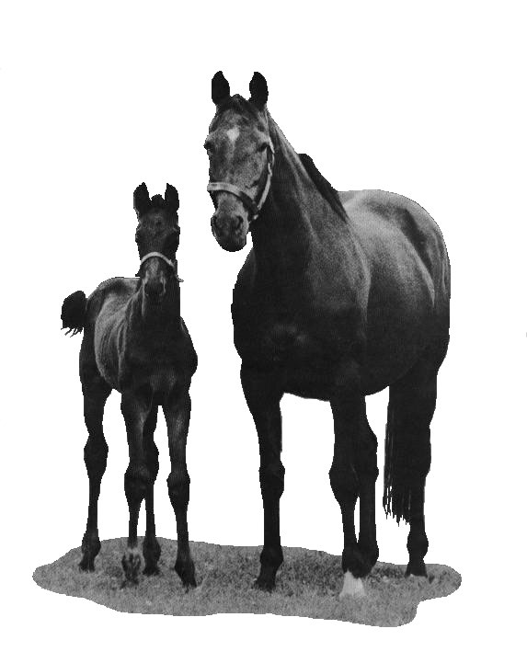

BATSFORD STUD

MARES DETAILS DOCUMENT for Season 2026

Name of Mare: …………………………………………………. Colour/Year foaled ………………………………………………..

SIRE ………………………………………………………… Dam ……………………………….... Passport No …………………………………

(PLEASE NOTE THE PASSPORT MUST ACCOMPANY THE MARE AT ALL TIMES)

Expected date of arrival on Stud …………………………….………

VISITING : …………………………………………………………...……

BARREN/MAIDEN/IN FOAL/WITH FOAL AT FOOT TO …………………………..……. Last Service Date ……………………………….

Registered Owner’s Name …………………………………………………………..…………………………………………………………………..

Name of Stud Manager and Emergency Contact No………………………………………………………………………………………………….....

Name and Address for Accounts and Correspondence ……………………………..……………………………………...............................................

Address where mare normally kept (if different from above) …………………………………………………………………………………………..

………………………………………………………………………………………………..…………………………………………………………..

Telephone/Fax and Mobile …………………………………………………………..E-mail …………………………….…………….

Is the Owner registered for VAT? If so VAT No ………………………….. Country of Registration ……………...............................

Is the Mare quiet at all times Y/N Has the mare been out of mainland Britain in the last 12 months Y/N

Has the mare been in contact with any infectious diseases Y/N

Has the mare been stitched Y/N Has she been on a stud in the last 12 months where there has been
a case of contagious or infections disease or ever been tested
positive for CEM/EVA. If so, supply written details. Y/N

Has the mare ever been on a stud where an outbreak of virus
abortion has occurred Y/N

Was she ever in foal at 42 days and later barren Y/N Is the mare fully vaccinated against Equine Herpes Virus-1
(EHV-1)? Y/N
Mares must also be vaccinated against Rotavirus at 8, 9 and 10 months
Has she ever aborted early/had twins/slipped Please note that the mare must be blood tested for EVA/EIA and
a foal? Y/N CEM in accordance with advice from a VET. Please supply copy certificate

Does she foal early/without warning Y/N Please ensure that the mare is up to date with Flu and
Tetanus vaccinations. Please supply details
Has she ever produced a jaundiced/Haemolytic Date …………….. Drug ………………………………….
Foal? Y/N
Last Worming Treatment and drug used
Is she short of milk after foaling? Y/N
Date …………….. Drug ………………………………….
Does she show readily to Teaser Y/N
Is the Mare insured Y/N
Has she ever had a blood transfusion Y/N
If so please supply Details separately Has the Mare suffered from any allergies or reactions to
to any drug or feedstuffs or any abnormalities. Y/N
If so please supply written details

All minor Veterinary sundries, wormers, farrier fees will be charged at cost. All Veterinary fees charged by Bourton Vale Equine Clinic will be invoiced direct to the Owners. All charges are subject to VAT at the current rate. NOTE: Whilst we strive to maintain the highest standard of Stud Management, every care will be taken with your Mare/Foal but the Stud cannot accept any responsibility for accident, disease, injury or death to the Mare/Foal whilst visiting this stud however caused.

I have read and agree to the terms, conditions and charges in both the Batsford Stud Boarding/Breeding Requirements 2021 documentation and in this Mare Particulars Form.

Signed …………………………………………………………. Print Name …………………………………………………….. Owner/Agent

Date …………………………………………………………….

BATSFORD STUD

Batsford, Moreton-in-Marsh, Gloucestershire GL56 9QF
Tel/Fax: 01608 651890 Mobile: 07899 957355
e-mail: Enquiries@batsfordstud.co.uk

TERMS AND CONDITIONS

- DEFINITIONS
In this Agreement ‘Mare’ means the Mare details on the Mare Particulars Form and where the context so admits or requires shall include any Foal of the Mare in utero, at foot or weaned. ‘Mare Owner’ means the person named as the owner of the Mare in the Particulars form and/or any duly authorised Agent of such person. ‘Boarding Stud’ means Batsford Stud (and, as appropriate, the proprietor thereof and includes, as applicable, any Agent of Batsford Stud and any Principal for whom Batsford Stud acts as Agent), named in this Agreement where the Mare is to be boarded for the purposes of this Agreement.
- GENERAL
Save as the parties may have otherwise agreed, these Conditions set out the terms upon which the Mare Owner has agreed to board the Mare with the Boarding Stud for the purposes of having the Mare covered by a Stallion which either stands at the Boarding Stud or at another Stud which the Mare is intended to visit by walking in from the Boarding Stud.
- MARE OWNER’S RESPONSIBILITIES
The Mare Owner’s responsibilities to the Boarding Stud include: (a) Providing the Boarding Stud with all information relevant to the Boarding Stud which the Boarding Stud may either request or might reasonably be expected to require for its protection and/or for the protection of other stock at the Boarding Stud and/or so as to give effect to the purposes for which the Mare is boarded at the Boarding Stud. (b) Paying the Boarding Stud’s agreed Keep charges and associated expenses according to the Stud’s terms of business. (c) Being fully conversant with the Horseracing Betting Levy Board’s (HBLB) Codes of Practice on contagious and infections equine diseases and acting at all times in full compliance with those Codes of Practice. (d) Delivering to the Boarding Stud with the Mare or as appropriate, before the Mare’s arrival at the Boarding Stud, all such documentation relating to the Mare as the Boarding Stud shall reasonably require, including without limitation, a valid passport (or photocopy thereof) and such swab and/or vaccination certificates as maybe required by the Boarding Stud and/or for compliance with the Codes of Practice referred to in Paragraph 3(c). (e) Removing the mare from the Boarding Stud either as agreed with the Boarding Stud or, in the absence of agreement, when reasonably required by the Boarding Stud.
- THE BOARDING STUD’S RESPONSIBILITIES
(a) To look after the Mare according to best practice and to that end (i) to employ sufficient Stud staff of skill and experience (ii) to take and maintain all reasonable precautions against infection occurring on the Stud in any Mares and Foals (iii) to ensure appropriate Veterinary care for the Mare and to observe and implement any recommendations in relation to the Mare given by the Boarding Stud’s veterinary advisers (iv to notify the Mare Owner promptly of any significant injury to the Mare, any diagnosis by a veterinary surgeon adverse to the Mare’s welfare and, in particular (but without limitation) any suspected infection in the Mare (v) to observe and apply all guidelines which may from time to time be issued by the Horserace Betting Levy Board or any other relevant body pertaining to the control or containment of disease in the Bloodstock Breeding Industry. (b) To accept all risks with regard to public and third party liability which the presence of the Mare on the Boarding Stud gives rise to save that if any third party or public liability claim shall arise in a case where the circumstances giving rise to that claim might have been avoided had relevant information, not disclosed by the Mare Owner, been disclosed, then the Mare Owner shall indemnify the Boarding Stud from and against the consequences of such claim.
5. MARE OWNER’S RIGHTS
(a) To expect of the Boarding Stud that the Mare will be kept and cared for by the Boarding Stud according to best practice. (b) To expect of the Boarding Stud that it will use its best endeavours to ensure that the purposes for which the Mare is boarded at the Boarding Stud are fulfilled. (c) To visit the Mare at the Boarding Stud by arrangement and on reasonable notice (except in cases of emergency). (d) Having paid all sums due to the Boarding Stud or reasonably incurred by the Boarding Stud on the mare Owner’s behalf to remove the Mare from the Boarding Stud at any time on reasonable notice subject as herein provided.
6. RIGHTS OF THE BOARDING STUD
(a) To refuse the acceptance of the Mare on the Boarding Stud on the grounds (i) that documentation in relation to the Mare which the Boarding Stud reasonably requires to be produced has not been produced (ii) that in the reasonable opinion of the Boarding Stud, the \Mare has any illness, affliction, vice or disposition which renders it a potential hazard to other stock at the Boarding Stud (iii) that the Mare has not been vaccinated as reasonably required by the Boarding Stud. (b) To require that the Mare be removed from the Boarding Stud (subject to the payment by the Mare Owner of all outstanding sums due to the Boarding Stud) if the Boarding Stud is of the reasonable opinion that, for whatsoever reason, the Mare represents a potential hazard to other stock at the Boarding Stud. (c) Save as specifically otherwise agreed, to carry out such appraisals, tests and procedures on the Mare and at such intervals as the Boarding Stud reasonably sees fit in order to monitor the Mare’s oestrus cycle and/or pregnancy status and/or to maximise the prospects of achieving a single full term pregnancy in the Mare and/or for any other purposes consistent with the purposes for which the Mare is boarded at the Boarding Stud. (d) To detain the Mare at the Boarding Stud at the cost and risk of the Mare Owner (without incurring any liability to the Mare Owner) in circumstances where the Mare’s detention at the Boarding Stud derives from a restriction or prohibition on the movement of horses whether or not such restriction or prohibition ahs the force of the law.
7. LIEN AND POWER OF SALE
(a) The Boarding Stud shall have, in addition to any statutory or other implied rights of lien, a specific lien over all goods and property of the Mare Owner in its possession including the Mare Owner’s horse(s) in its possession in respect of the Keep fees, Foaling fees and other costs and expenses charged by the Boarding Stud in respect of the keep of the Mare. (b) The Boarding Stud shall be entitled on the expiry of 21 days notice to the Mare Owner to dispose of the Mare Owner’s property as it thinks fit and to apply the proceeds towards (i) all unpaid invoices (ii) expenses of storage and/or keep of the horse(s) during the period of retention under lien and (iii) other costs including the costs and expenses of the sale. Thereafter the Boarding Stud shall account to the Mare Owner for any surplus and upon so doing shall be discharged from all liabilities under this Agreement. (c) The Boarding Stud shall be under no duty of care towards the Mare Owner in exercising its rights of disposal. The Mare Owner irrevocably appoints the Boarding Stud as his attorney for the purpose of the exercise of the power of sale under this clause and agrees to do all such acts as may be required by the Boarding Stud and to sign all documents necessary to ensure that the Boarding Stud may be registered as Mare Owner of the horse(s) in exercise of the power of sale.
8. ACCIDENTS, ILLNESS AND DEATH
(a) In the absence of negligence on the part of the Boarding Stud, its servants or agents, the Boarding Stud shall, in no circumstances, be liable for the death of the Mare or for any accident, injury or illness suffered by the Mare and it shall be for the Mare Owner accordingly to insure the Mare against such risks and for such value as it considers fit. (b) In the event of the Mare being determined by the Boarding Stud’s veterinary advisers to be suffering from an injury, condition or illness necessitating destruction, the Boarding Stud is authorised to procure that the Mare is humanely destroyed as quickly as possible having first made all reasonable efforts (except in a case where immediate destruction is imperative on humanitarian grounds) to establish contact with the Mare Owner and/or with any insurers detailed to the Boarding Stud by the Mare Owner with a view to reporting the circumstances and the course of action necessitated by the circumstances.

Any dispute arising from these terms and conditions shall be a matter strictly between the parties to that dispute, shall be governed by English Law and shall be subject to the exclusive jurisdiction of English Courts save that any award or other Order of an English Court in relation to any such dispute may be enforced in any jurisdiction anywhere in the world.

A person who is not party to this agreement shall have no right under the Contracts (Rights of Third Parties) Act 1999 to enforce any term of this Agreement. This clause shall not affect any right or remedy of any person which exists or is available otherwise than pursuant to that Act.

